PROPOSSED NAVIGATION STRUCTURE IN EDUCATION ASSESSMENT

High Level Work flow
Customer care
(Confirming receipt and signing in)
Service point
(Educational Assessment)
Multidisciplinary
Intervention
(Placement, report writing)
External Referral
(Medical Assessment)
Internal Referral
(OT, PT, Nut etc...)
Follow up plan

Detailed Workflow for New client
Client enters signposted service point

Service Point Customer Care Desk/Departmental Receptionist
Retrieve and review the client record in HMIS, confirming: Basic biodata and triaging outcome, Signposted service and queue, Payment status and coverage confirmation, referral notes from intake or payment administrator.
- Confirm service availability
- Sign in the client
Generate a daily service summary
(To be done at the intake in collaboration with customer care).
System Notes:
- Service attendance is logged automatically once the client is signed in.
- Deferred or missed services should trigger a system alert for follow-up by intake in collaboration with the customer care.

Initial/Baseline assessment
Specific assessment as applicable
External referral (school, health & rehab facilities, KISE satellite centers, outreach, etc.)
Internal referral (Signposting, Billing, payment, admission to referred service)
Intervention (assessment & placement/report writing, therapeutic, clinical, AT prescription, dispensing)
Multidisciplinary (Suggested to be done twice a month with booking and a committee to be on set.)

Establish a follow up plan
Service Point Stage: Customer Care and Service Provider  Purpose: To confirm client readiness for service, ensure accurate linkage between payment and service delivery, to guide the clients to the appropriate assessment point/office.  Customer Care / Service Point Reception Desk  Key Responsibilities:  - Retrieve and review the client record in HMIS, confirming:  - Triage outcome.  - Service booking and queue details.  - Payment status and coverage confirmation.  - Relevant referral notes from intake or payment administrator.  - Confirm service availability  - Sign in the client  Generate a daily service summary  (To be done at the intake in collaboration with customer care).  System Notes:  - Service attendance is logged automatically once the client is signed in.  - Deferred or missed services should trigger a system alert for follow-up by intake in collaboration with the customer care. | Baseline / Initial Assessment – Service Provider  - Conduct baseline or initial assessment specific to the client’s referral category (therapy, educational assessment, assistive technology, or other specialized services).  - Review information from intake, triage, and previous records to ensure continuity of care.  - Administer the service point standard initial/baseline assessment tools to establish baseline function, learning profile, or performance level, and needs. (holistic screening & assessment).  - Administer or refer to specific assessment as applicable  - Record findings and develop an individualized intervention plan or service pathway where applicable.  - Update HMIS with assessment data, including:  - Assessment type and date.  - Key findings or summary notes.  - Planned interventions, frequency, and follow-up schedule.  - Where services cannot commence (e.g., missing documentation, incomplete payment, or absentee provider), record the reason and reschedule as appropriate.  System Notes:  - Baseline assessment data should auto-populate the client’s service history and feed into progress tracking tools.  - Each entry is time-stamped and linked to the specific service provider’s HMIS profile.  Summary Workflow  - Client arrives at Service Point → Customer Care verifies record, booking, and payment status.  - Client is guided to assessment room/office → Service Provider conducts baseline or initial assessment.  - Assessment outcomes and next steps recorded in HMIS and reflected in the client’s service plan.  Assessment Summary Workflow  - Rapport setting.  - Check for required documents (books, medical reports etc.)  - Understand clients concerns while taking the background information.  - Involve the client in different activities.  - Decide on the screening tools to use.  - Interpret the results.  - Decision making; - Internal referral.  - External referral.  - Report and placement writing.  - Multidisciplinary (Suggested to be done twice a month with booking and a committee to be on set.)  - Follow up plan.

Detailed Workflow for Old/Return Client
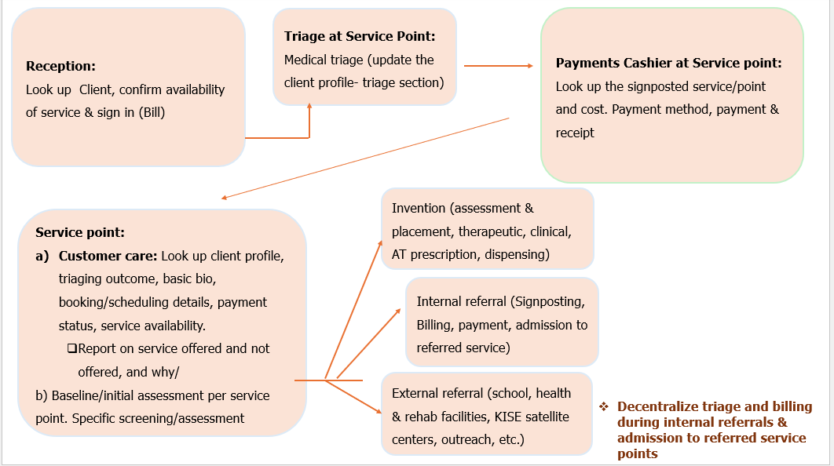
Re-Assessment Summary workflow
- Rapport setting.
- Review previous assessment data. i.e. medical reports, background history, tools used and any other relevant information.
- Understand clients concerns for returning.
- Gather relevant information for re-assessment.
- Decision Making; - External referrals.
  - Internal referrals.
  - Report and placement writing.
  - Counselling.
  - Multidisciplinary.
- Follow up.

